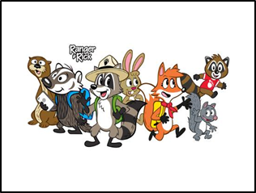

Dear Kindergarten Parents,

Welcome to the Kindergarten Explorers Room! My name is Carrie Kovac and I will be your child’s kindergarten teacher for the 2023-2024 school year. I am very excited to be working with you and your child. I am here for anything you need to ensure your child’s success in kindergarten. We will get to know each other better by having ongoing communication through participating in home visits and using the communication tool Class Dojo. I hope to get to know each of you as the school year goes on and as we collaborate to help your child grow socially and academically.

I am looking forward to teaching your child in kindergarten this year! I will be working extremely hard to establish our classroom as a happy, challenging, comfortable, safe learning environment where we all do our personal best.

Our classroom’s logo is Explorers. In this classroom, we will explore learning in different areas such as academics, social/emotional, and nature. Your child will blossom and grow as a reader by learning to identify letters, sounds, sight words and blending.  They will learn to add, subtract, and identify place value, money, and time.  I enjoy teaching my students through hands on experiences. I am so excited about all of the wonderful things we are going to experience and explore this year. I am looking forward to meeting you and your child on our **Meet the Teacher Night- August 18th , 4:30-6:30 pm.**

Along with this letter, you will receive an Explorer tag. Please have your child wear the Explorer tag for the first week of school. This will make it easier to identify your child’s classroom.

Below is a list of supplies your child will need to bring on the first day of school. If you ever have any questions or concerns, please do not hesitate to contact me. My email address is [carrie.kovac@slps.org](mailto:carrie.kovac@slps.org). I will be checking it over the summer.

Sincerely,

Carrie Kovac

**Supply List *Classroom Wish list\***

-Book bag (Standard size( not small) so folders and notebooks can fit) 2 -3 oz. containers of

-Change of clothes playdough

-Black Dry Erase Marker (for student use) 1 roll of paper towels

-(2) Glue sticks

-(2) Sanitizing Wipes

- Hand Sanitizer

-(2) Boxes of tissue